Application Number | 07/2017/2486/FUL
Address | Land Off Shaw Brook Road and  Altcar Lane  Leyland  Lancashire
Applicant  Agent | Redrow Homes Ltd.  Mrs Nichola Burns  14 Eaton Avenue  Buckshaw Village  Leyland  PR7 7NA  United Kingdom
Development | Formation of new vehicular access onto Leyland Lane
Officer Recommendation Officer Name | Approval with Conditions Mrs Catherine Lewis
Date application valid | 22.09.2017
Target Determination Date | 22.12.2017
Extension of Time N/A
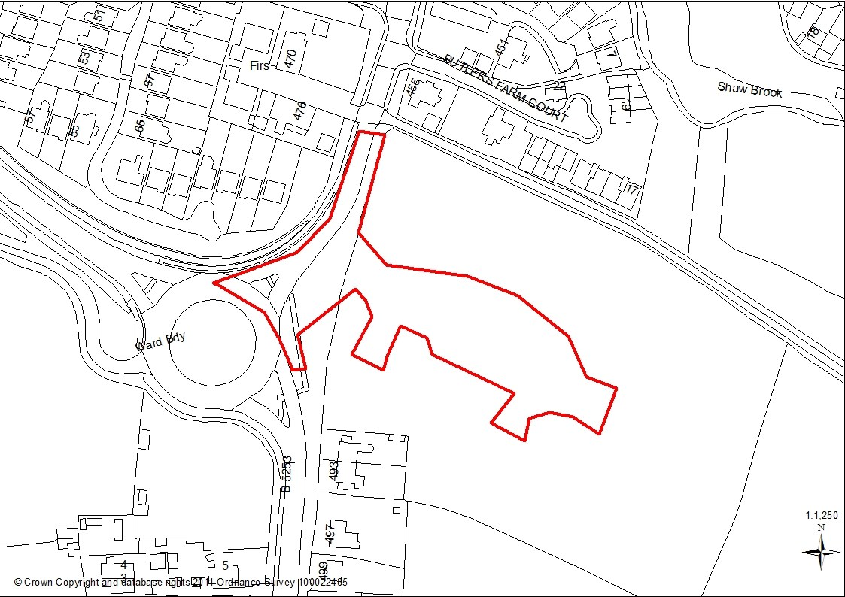

1.0 Report Summary
1.1 Outline planning permission was granted for up to 400 dwellings and associated infrastructure following the successful completion of a Section 106 Agreement in September 2017. As part of this approval the design of the access demonstrated a change to the alignment of Leyland Lane running north from the roundabout to sweep into the development site.
1.2 The current application provides for the same access design but with more detailed drawings and is submitted as a separate full planning application to enable the early delivery of the infrastructure required for the housing development.
1.3 The Preston, South Ribble and Lancashire City Deal was the first of 20 second wave City Deals to be agreed and was signed in September 2013. New investment of £434 million will expand transport infrastructure in Preston and South Ribble at an unprecedented rate, driving the creation of some 20,000 new jobs and generating the development of more than 17,000 new homes over the next ten years.
1.4 Key to the success of City Deal is for development sites to come forward to deliver houses which in turn provides funding towards the costs of the infrastructure. The wider Site P at Altcar Lane is one such site. The proposed development would enable the delivery of the site to be accelerated, to provide a significant number of residential dwellings, which will help South Ribble deliver part of its requirement towards the City Deal housing target.
1.5 LCC Highways has raised no objection and the proposal would not have an undue impact upon the amenities of neighbouring properties and there would not be any significant highway safety, flooding or amenity implications. The proposed development is deemed to accord with the NPPF and, policies 1, 22, 27 of the Central Lancashire Core Strategy and policies D1, G16, and G17, of the South Ribble Local Plan.
1.4 Therefore, the officer recommendation is approval subject to conditions.

2.0 Site and Surrounding Area
2.1 The site is located approximately 2km south of Leyland town centre adjacent to the roundabout with Schleswig Way (B5253). The application site forms part of the road known as Leyland Lane and the northwest corner of the field adjacent to Shaw Brook Road.
2.2 The nearest residential property known as 58 Park Avenue is located some 10 metres away from the existing pavement on the western boundary, to the north east is Shaw Brook Road, to the south is the roundabout with the agricultural field forming the eastern boundary.

3.0 Planning History
3.1 A Masterplan has been endorsed by the Planning Committee in March 2016 for up to 600 residential properties which included two access points one to the north to serve the Redrow Homes development and one to the south off Leyland Lane to serve the Homes and Community Agency (HCA).
3.2 Outline planning permission has been granted for the Redrow Homes application for up to 400 dwellings to be served from the northern access point (Ref: 2016/0591/OUT).
3.3 Outline planning permission has also been granted for the Home and Community Agency(HCA) application for up to 200 dwellings to be served from the south eastern access point (Ref: 2016/0310/OUT). The two residential sites would be linked via an internal access road.

4.0 Proposal
4.1 Planning permission is sought for the realignment of the existing road network to provide for a new access arrangement to serve the residential development known as Site P at Altcar Lane.
4.2 The realignment would provide for Leyland Lane to become a Give Way approximately 55m north of the existing roundabout. This alteration would give priority to provide for the road to sweep into proposed residential development.
4.3 The plans demonstrate the following:
- Trees and hedgerow to be removed to the existing hedgerow to form the new access.
- The existing north and south bound bus stop upgraded
- Pavements to be realigned to address the proposed housing development
- Proposed tactile paving to the Give Way junction
- Signage advising on speed limits

5.0 Summary of Supporting Documents
5.1 The applicant has provided the following documents and reports in support of the application:
- Flood Risk Assessment dated 2015
- Tree Survey Report dated September 2014
- Updated Ecology Assessment ERAP, Sept 2017

6.0 Summary of Publicity
6.1 The application has been advertised in the newspaper, by five Site Notices and a total of 53 neighbouring properties have been consulted.
6.5 A total of 4 letters of objection have been received raising the following summarised points:

Traffic
- Concern about the proposed new access which would be located in a
dangerous position to an existing large and busy roundabout.
- Although existing speed 40mph more traffic calming is required
- Have the highway issues really been considered.
- A new access would be safer off the roundabout.
- There have been many near misses and there is concern that this development would not address this issue but could make the situation worse.
- The speed of the cars from Schleswig Way accessing Leyland Lane needs to be addressed.

Drainage
- Concern about the flooding as the site has prehistoric clay there is no natural land drainage.
- The contractor’s compound could cause the site to cause flooding.

Other Matters
• Concern that the present infrastructure including schools would not cope with the additional development.

7.0 Summary of Consultations
7.1 LCC Highways: Initially raised concerns that the plans did not demonstrate the details as submitted and approved in principle with the outline application. Revised plans have been received which demonstrate the original details and are therefore supported subject to a condition requiring a more detailed design to be submitted for approval. The revised drawing road geometry is acceptable as an in principle drawing for planning purpose and proposed development as indicated on the drawing is acceptable subject to a condition controlling the detailed design and an advisor note.
7.2 Environment Agency: No comments to make on the application for the proposed access.
7.3 LCC Local Lead Flooding Authority (LLFA): No comments received to date any will be reported at the meeting.
7.4 South Ribble Council Consultees:
7.4.1 Environmental Health: No comments received to date, any will be reported at the meeting.
7.4.2 Tree Officer: No objection to the proposal.
7.4.3 Ecology Services: Initially raised concerns about the loss of an important
Hedgerow. Following The applicant has advised that The Updated Ecology Assessment (ERAP, Sept 2017) submitted with the full application explains that landscape planting will be carried out outside the red line to compensate for the loss of a short section of hedgerow (40m) and new habitat suitable for nesting birds will be provided in the wider residential development (para 6.2). Given that the circumstances of this application are quite unique, it is considered that a pragmatic response to the need for compensatory planting within the red line should be taken. Ecology Services accept the comments and are satisfied provided that there is mitigation for the hedgerow.

8.0 Policy Background
8.1 The overarching theme of the NPPF is one of a presumption in favour of sustainable development with three dimensions: economic; social and environmental. The Framework recognises that the planning system can contribute to this by providing a supply of housing required to encourage vibrant and healthy communities (Paragraph 7).
The Framework states that “housing applications should be considered in the context of the presumption in favour of sustainable development. Relevant policies for the supply of housing should not be considered up-to-date if the local planning authority cannot demonstrate a five-year supply of deliverable housing sites.” Paragraph 47 of the NPPF states that local planning authorities should identify a supply of specific deliverable sites sufficient to provide five years’ worth of housing against their housing requirements.

8.2 Central Lancashire Core Strategy
Policy 1: Locating Growth focuses growth and investment on brownfield sites in the main urban areas, whilst protecting the character of suburban and rural areas.
Policy 22: Biodiversity and Geodiversity seeks to conserve, protect, enhance and manage the biological and geological assets of an area.
Policy 27: Sustainable Resources and New Development seeks to ensure sustainable resources are incorporated into new development.

8.3 South Ribble Local Plan 2012-2026
Policy D1: Allocation of Housing Land identifies and allocates land for residential development, as required by the NPPF.

Policy G13: Trees, Woodlands & Development has a presumption in favour of the retention and enhancement of existing tree, woodland and hedgerow cover on site.
Policy G16: Biodiversity & Nature Conservation seeks to protect, conserve and enhance the borough’s biodiversity and ecological network resources.
Policy G17: Design Criteria for New Development permits new development provided that the development does not have a detrimental impact on neighbouring buildings or on the street scene by virtue of its design, height, scale, orientation, plot density, massing, proximity, use of materials. Furthermore, the development should not cause harm to neighbouring property by leading to undue overlooking, overshadowing or have an overbearing effect; the layout, design and landscaping of all elements of the proposal, including any internal roads, car parking, footpaths and open spaces, are of a high quality and will provide an interesting visual environment which respects the character of the site and local area; the development would not prejudice highway safety, pedestrian safety, the free flow of traffic, and would not reduce the number of on-site parking spaces to below the standards stated in Policy F1. Furthermore, any new roads and/or pavements provided as part of the development should be to an adoptable standard; and the proposal would not have a detrimental impact on landscape features such as mature trees, hedgerows, ponds and watercourses.
9.0 Material Considerations

9.1 Principle of Development
9.1.1 The site has been identified for residential development under Policy D1 in the South Ribble Local Plan adopted in 2015. A masterplan has been adopted and outline planning permission has been granted for residential development including the means of access. Therefore, the principle of the means of access has been established and meets the aims of the National Planning Policy Framework which promotes sustainable development and supports Core Strategy policies 1, 4 and 7, and Local Plan Policy D1.

9.2 Detailed Scheme
9.2.1 The current application has been brought forward by Redrow Homes to enable the access arrangements and approximately the first 100metres of the internal estate road to be constructed. The applicant has advised that the purpose of the application is to enable the early delivery of infrastructure, and the internal estate road which would allow an earlier site start and therefore earlier completion of the first dwellings.
9.2.2 Vehicular access for the development is proposed via a new priority junction on Leyland Lane to the northeast of Schleswig Way. The proposed vehicular access comprises a modified junction with Leyland Lane close to the Schleswig Way roundabout. The proposal is to change the alignment of Leyland Lane north from the roundabout to sweep into the application site with the existing Leyland lane creating a priority junction to the north.
9.2.3 LCC Highways initially objected to the scheme as the plans did not reflect some of the off-site highway improvements provided as part of the outline approval, for instance the signage for the speed restrictions for the area. Revised plans have been received demonstrate speed restrictions and the location of upgraded bus stops and which now satisfy LCC Highways and subject to a condition requiring a detailed design to be produced and agreed with LCC the scheme is now considered acceptable.
9.2.4 Concern has been expressed that the impact upon the highway network has not been truly considered. The outline application was accompanied by a Transport Assessment (TA). The Transport Assessment (TA) utilised development traffic trip generation and trip distribution agreed with LCC during the scoping process for the adjoining HCA site, so these parameters were considered acceptable. It is considered that the principle of the access has been previously supported and approved, therefore the scheme is considered acceptable.
9.2.5 Concerns has been expressed that there have been near misses near the proposed road changes. LCC Highways has advised that there is only one collision in the last 3 years on the Police accident record. This appears to be at Springfield Road junction with one slight injury. In was August this year, daytime, fine weather so looks like driver error turning onto Leyland Lane and was recorded as human error. Furthermore, the proposed changes could slow down the traffic as it enters Leyland Lane.
9.2.6 Concern has been expressed about the flooding of the site. The application is accompanied by the Flood Risk Assessment dated February 2015 which was considered as part of the outline application. Lancashire County Council in their capacity as the Lead Local Flood Authority (LLFA) commented on the application. The Flood and Water Management Act 2010 sets out the requirement for LLFAs to manage
'local' flood risk within their area. 'Local' flood risk refers to flooding or flood risk from surface water, groundwater or from ordinary watercourses.
9.2.7 The LLFA raised no objection to the outline application subject to the imposition of conditions controlling a surface water management and a maintenance lifetime plan. However, as this application relates solely to the access junction and a small part of the internal estate road, the submission of details to control flooding and mitigation measures through appropriate conditions would be addressed as part of the reserved matters application.

9.4 Relationship to Neighbours
9.4.1 The closest residential properties abut the western boundary of the application site and this boundary has a number of trees and hedges which currently provide some screening. Other residential properties which back on to Shaw Brook Road are also well screened by mature trees bordering the northern boundary of the application site.

9.5 Wildlife
9.5.1 The application would require a length of hedgerow adjacent to eastern side of
Leyland Lane to be removed as part of the alterations to the road junction. Ecology Services has been consulted and concede that under this application it would be difficult to secure planting within the application site and that as part of the residential development provision has been made for mitigation.

9.15 Tree Issues
9.15.1 A survey and assessment of all the trees has been undertaken. The Council’s tree officer has raised no objection to the scheme.

10. Other matters
10.1 Concern has been raised about the location of a compound and any potential flooding that could occur as part of construction activities. Construction compounds are classed as permitted development but a condition controlling this aspect could be imposed and the applicant has not objected to such a condition. Furthermore that as part of this access works planning application the application has confirmed that no work, including site stripping, would be undertaken outside the red line of the full application site, if those works are carried out in isolation (as now planned).
10.2. Concern has been raised about the lack of infrastructure and the lack of school places given the proposed development. This aspect has been addressed as part of consideration for the outline planning permission.
10.3 The Preston, South Ribble and Lancashire City Deal was the first of 20 second wave City Deals to be agreed and was signed in September 2013. New investment of £434 million will expand transport infrastructure in Preston and South Ribble at an unprecedented rate, driving the creation of some 20,000 new jobs and generating the development of more than 17,000 new homes over the next ten years.
10.4 Key to the success of City Deal is for development sites to come forward to deliver houses which in turn provides funding towards the costs of the infrastructure. The wider Site P at Altcar Lane is one such site. The proposed development would enable the delivery of the site to be accelerated, to provide a significant number of residential dwellings, which will help South Ribble deliver part of its requirement towards the City Deal housing target.

11. CONCLUSION
11.1 The delivery of this site for residential development supports the aims and objectives of the Lancashire, Preston and South Ribble City Deal. The site is part of a wider housing site known as Site P under D1 of the adopted South Ribble Local Plan 2015.
11.2 The application seeks to bring forward the access arrangement to speed up the delivery of the site. The proposed development would not have an undue impact upon the amenities of neighbouring properties and there would not be any significant highway safety or amenity implications. Issues of ecology, surface water, flood risk, construction and design would be controlled through appropriate conditions. The proposed development is deemed to accord with the NPPF and, policies 1, 4, 5, 6, 17, 22, 26 and 29 of the Central Lancashire Core Strategy and policies A1, D1, F1, G7, G10, G13, G14, G16 and G17 of the South Ribble Local Plan.
11.3 Therefore, officer recommendation is approval subject to conditions associate with highways and the location of the compound.
RECOMMENDATION:
Approval with Conditions.
RECOMMENDED CONDITIONS:
- The development hereby permitted must be begun not later than the expiration of three years beginning with the date of this permission.
REASON: Required to be imposed pursuant to Section 91 of the Town and Country Planning Act 1990.
- The development hereby approved shall be carried out in accordance with the approved plans:
Drawing Number UW-LP-01 entitled "Location Plan"
Drawing Number UW-SA-01 entitled "Proposed Access"
Drawing Number SCP/16469/0000/001 Rev A entitled "General Arrangement" Drawing Number SCP/16469/0200/001 Rev A entitled "Site Clearance"
Drawing Number 4829.02 entitled “Tree Survey and Root Protection Areas”.
or any subsequent amendments, to these plans that have been agreed in writing by the Local Planning Authority.
Reason: For the avoidance of doubt and to ensure a satisfactory form of development.
- No part of the development shall be commenced until all the highway works for the site access and works of road improvement within the adopted highway and the estate road up to and including the first internal road junction have been constructed in accordance with a detail construction design and schedule of scheme delivery works that shall be submitted to and approved by the Local Planning Authority in consultation with the Highway Authority as part of a section 278 agreement, under the Highways Act 1980.
Reasons: In order to satisfy the Local Planning Authority and Highway Authority that the final details of the highway scheme/works are acceptable before work commences on site and to enable all construction traffic to enter and leave the premises in a safe manner without causing a hazard to other road users.

RELEVANT POLICY
NPPF National Planning Policy Framework
1 Locating Growth (Core Strategy Policy)
22 Biodiversity and Geodiversity (Core Strategy Policy)

27 Sustainable Resources and New Developments (Core Strategy Policy)
POLD1 | Allocations of housing land
POLG13 | Trees, Woodlands and Development
POLG16 | Biodiversity and Nature Conservation
POLG17 | Design Criteria for New Development

Note:
1. The grant of planning permission will require the applicant to enter into an appropriate Legal Agreement, with the County Council as Highway Authority. The Highway Authority hereby reserves the right to provide the highway works within the highway associated with this proposal. Provision of the highway works includes design, procurement of the work by contract and supervision of the works. The applicant should be advised to contact Highways Development Support team at Cuerden Mill Depot, Cuerden Way, Bamber Bridge, Preston PR5 6BJ in the first instance to ascertain the details of such an agreement and the information to be provided.

